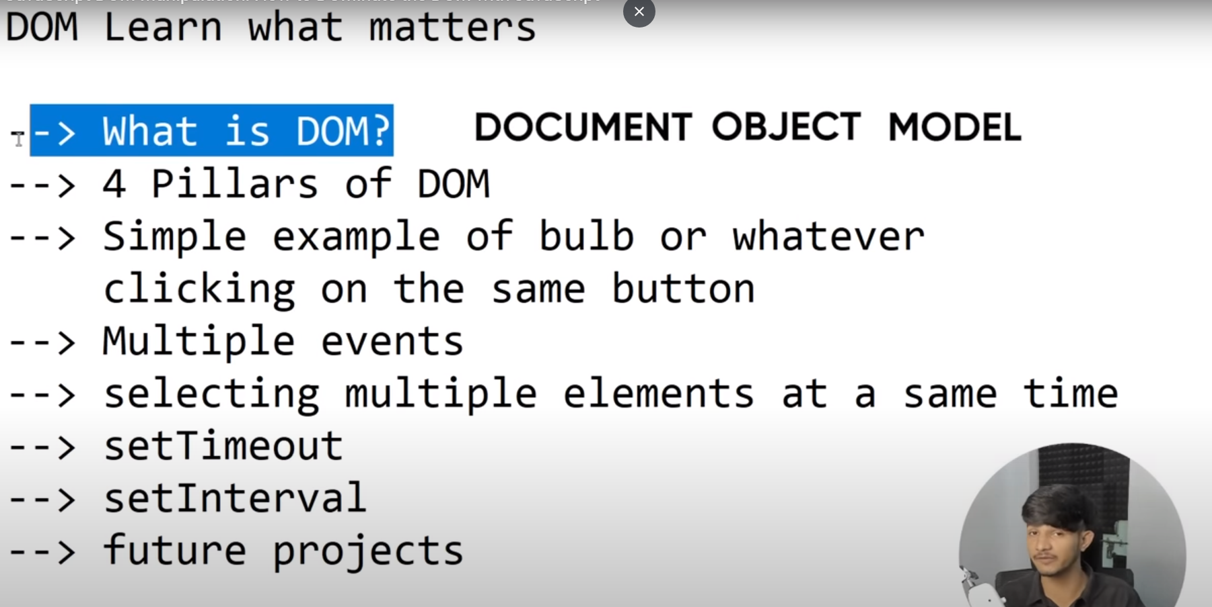

Dom er 4pillers

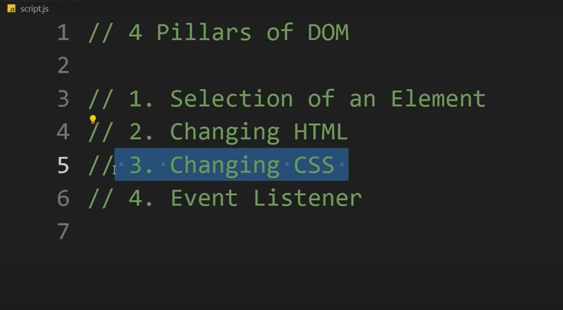

Console e h1 element select hoise

1.selection of element

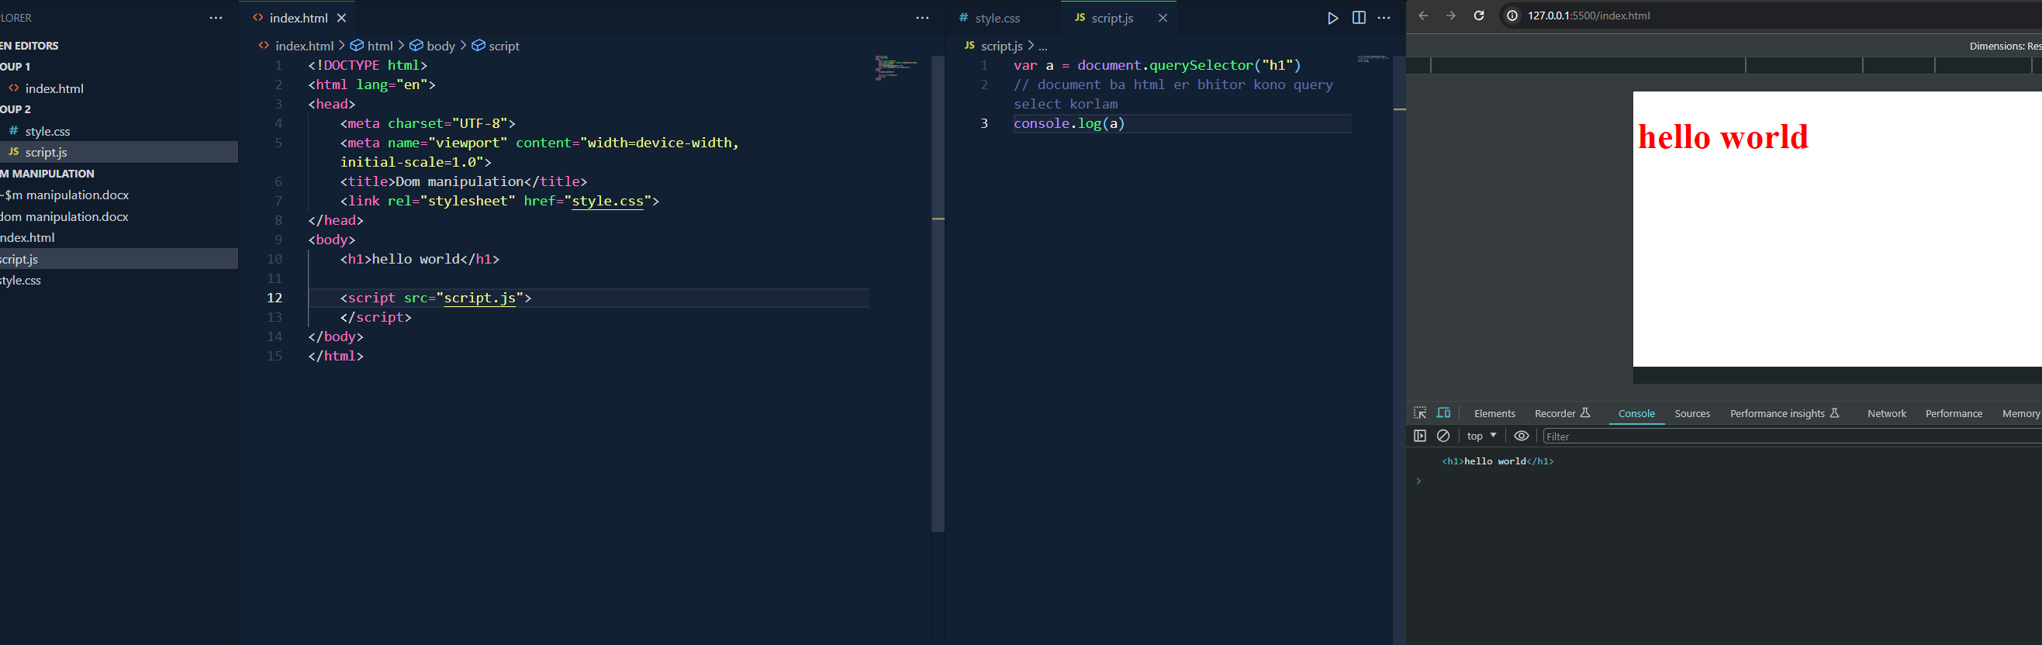

2.html changing ..age query select kore shei tag er element change korbo innerhtml diye

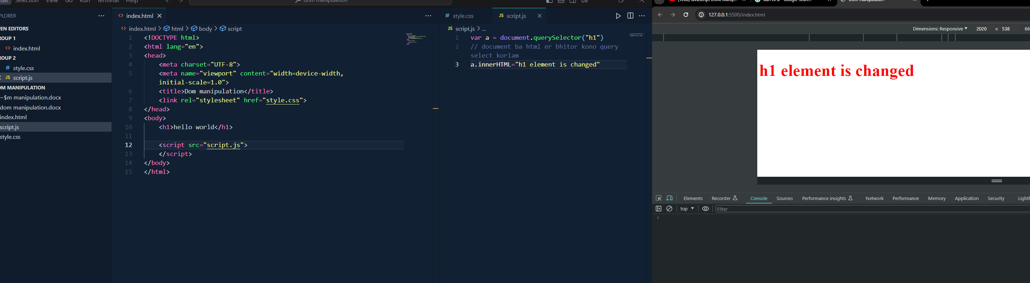

3.Css changing..same html change er motoi but a.style.styleAttributes

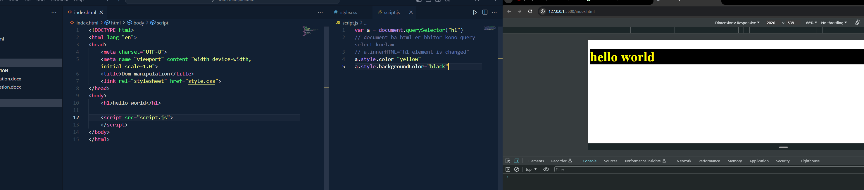

4.event listener…event listener add korte hbe 2 ta parameter (type,function)

Click korle console e lekha uthbe

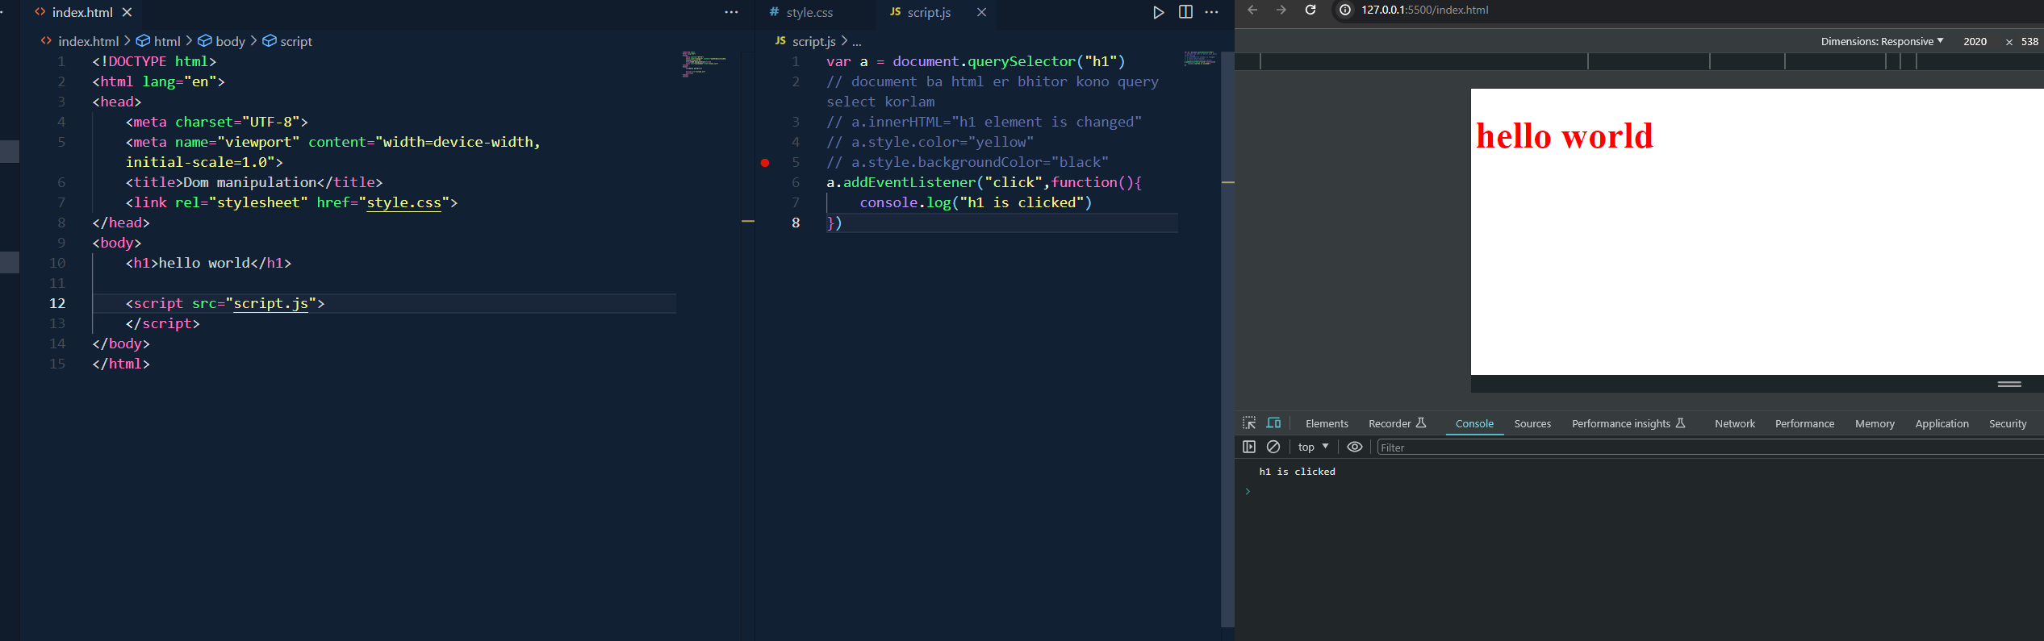

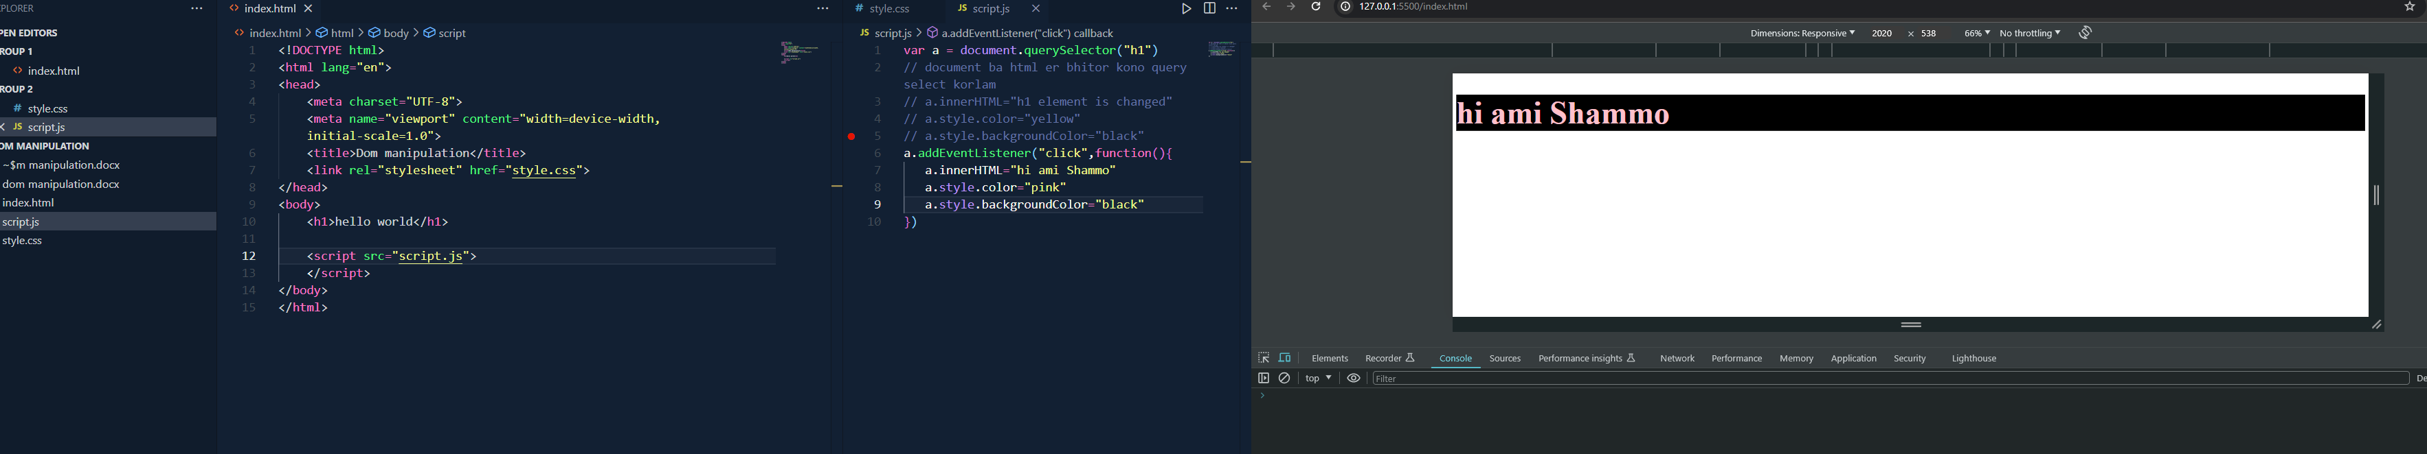

Click er por function er bhitor shb change hoise

**4pilllars done**

**--Simple example of bulb or whatever**

**Var bulb.btn,flag for logic and toggle kora jonno**

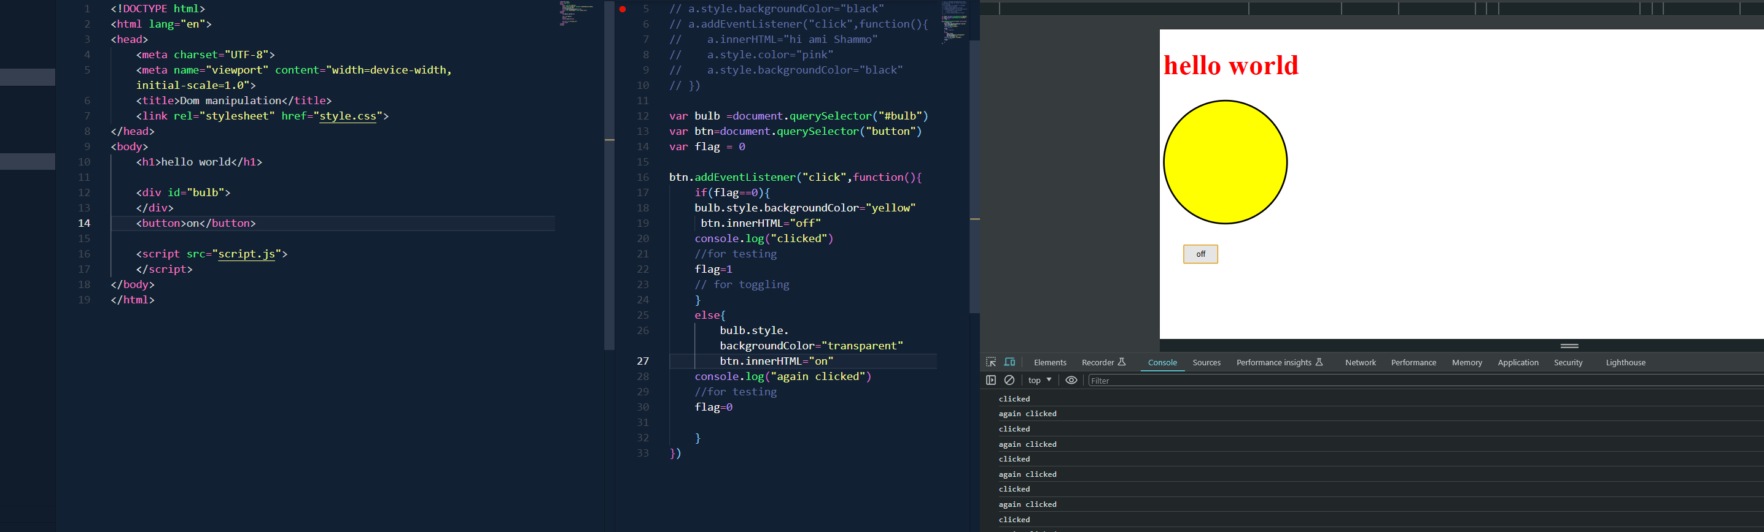

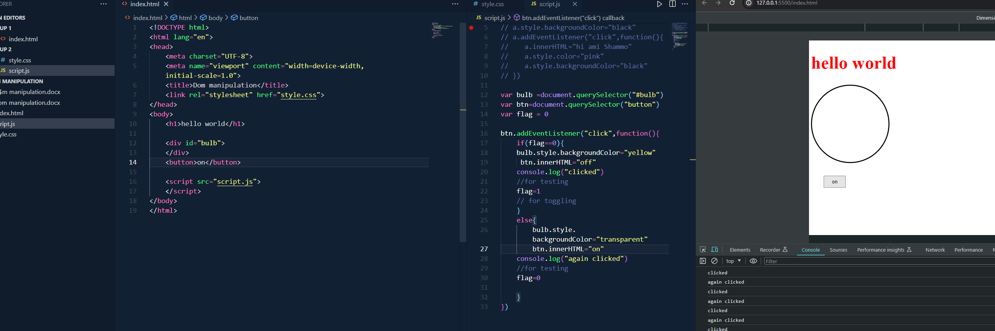

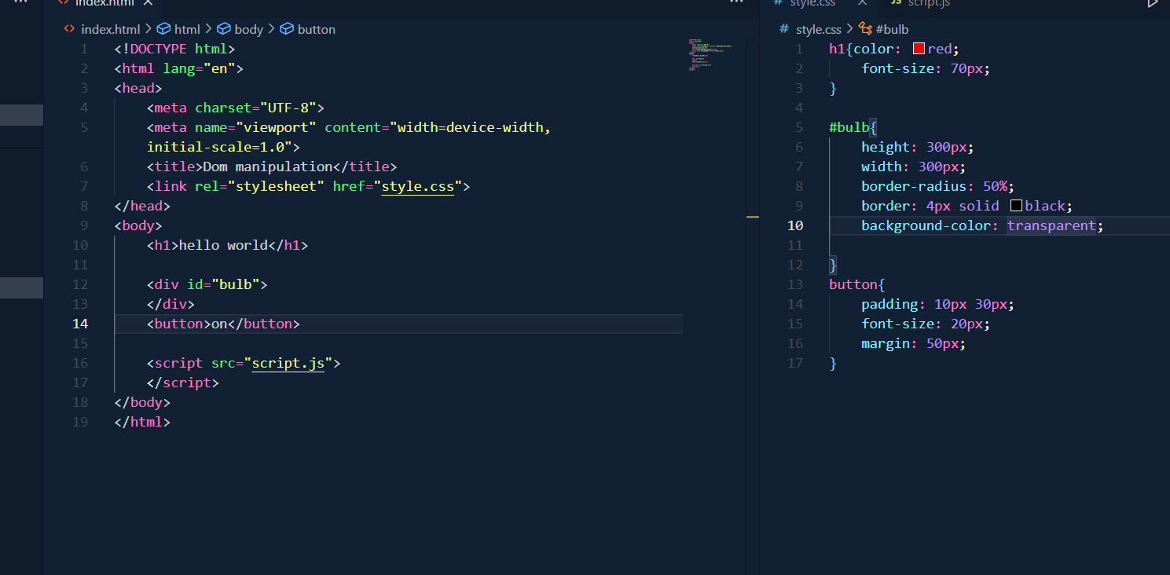

--Multiple Event(event listener er moto) nwill be discussed later

--Selecting Multiple elements at a same time

Node list onek ta array er moto

Amake multiple element selectkorte queryselectorall dite hbe

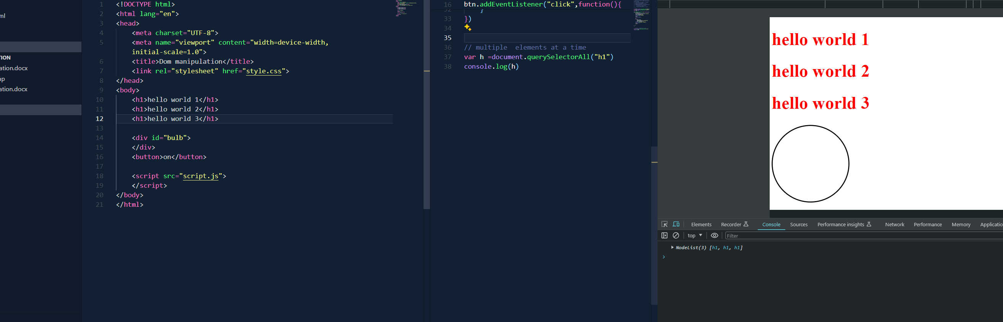

For each function is not necessary now

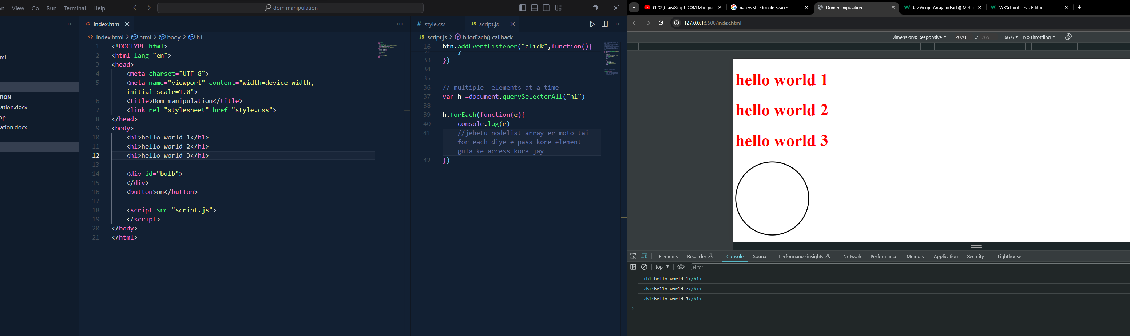

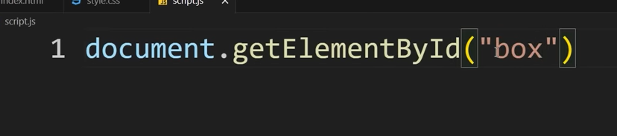

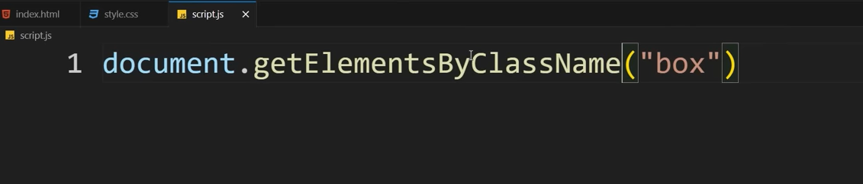

Id r class name queryselector na likhe ebabeo likhte pari

--difference between innerHtml vs textContent

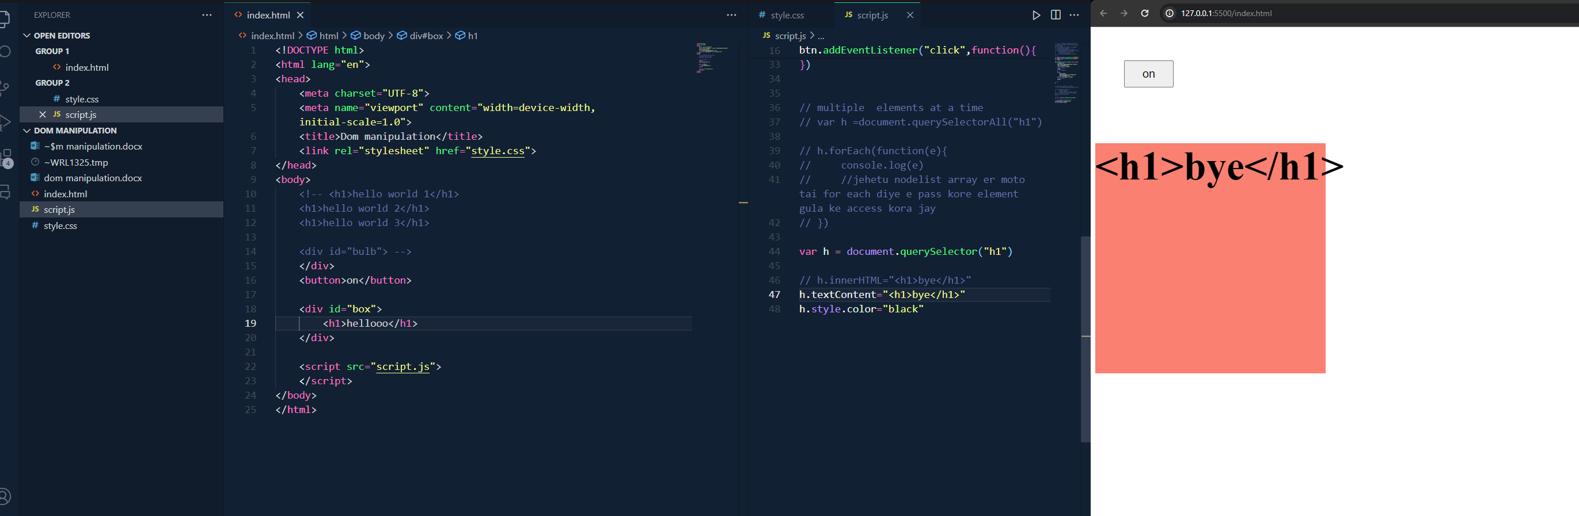

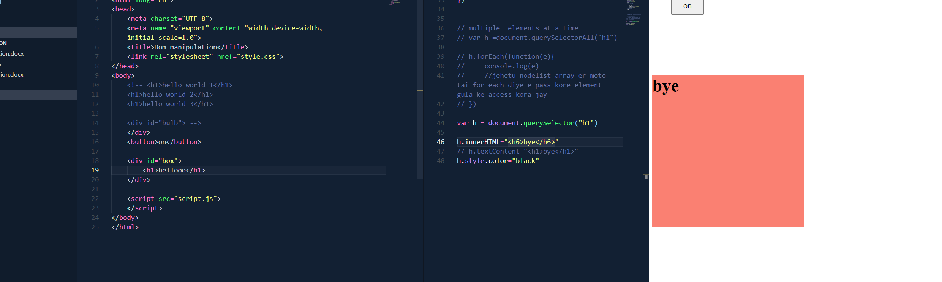

Shudhu text change korte hole textContent r html change korte innerhtml r tag lekha uthbe na